Threat management and cybersecurity Resources

Key contributors:

Devon Brown

Daniel Garza

Candan Martin

April/23/2022

**Executive Summary**

The purpose of this project is to test the efficiency of detecting vulnerabilities using OpenVAS, Nessus, and Metasploit. We used 3 different operating systems Metasploitable, Fedora, and CentOS to test the efficiency of our vulnerability assessment tools. We used Metasploitable for its numerable vulnerabilities as our baseline least secure system. We used Fedora because it is used to host servers so we wanted to see how secure the system would be. We used CentOS because it is widely used by scientists so we wanted to compare its security to Fedora and Metasploitable. Candan will be using Nessus, Devon will be using OpenVAS, and Daniel will be using Metasploit.

We focused on Metasploitable because …

**These are the results that we got:**

**OpenVAS:**

Intro: …

Experimental Procedure:

It consists of (X#) steps

Step 1.

…

-Image display of the report at the end

OpenVAS Report Results:

Metasploitable

(Image of Results)

Fedora

(Image of Results)

CentOS

(Image of Results)

*Full Report on Git-Hub*

**Nessus:**

Intro:

Candan used the Nessus vulnerability assessment tool to scan Metasploitable’s IP address and identify vulnerabilities in Metasploitable’s operating system. After scan, Nessus provided insight on the vulnerabilities found and Candan generated it’s general report

Experimental Procedure:

* It consists of 11 steps

Step 1.

Use ifconfig command in Metasploitable to identify IP address for metasplotable. Fig 1.1

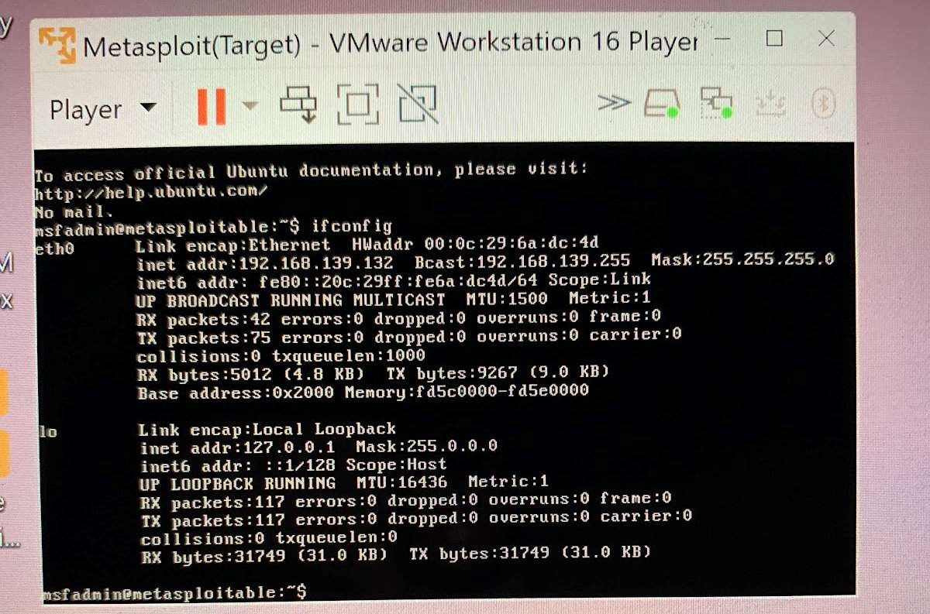

Fig 1.1

Metasploitable ip address is displayed

Step 2:

Open Kali Linux terminal and use command “ping “ to check for a connection from metasploitable our target machine. Fig 1.2

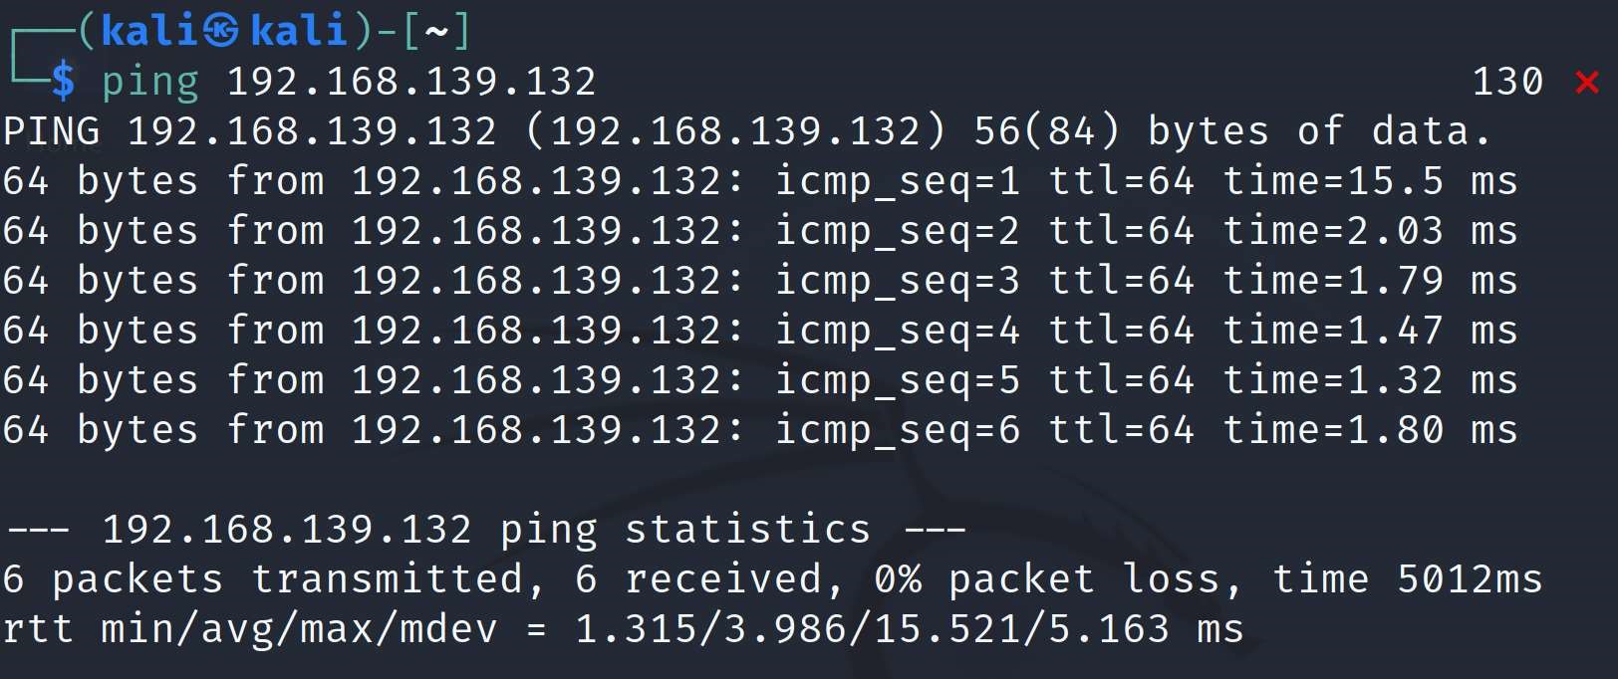

Fig 1.2

Step 3.

Open the Nessus application in the Kali Linux VM.

Step 4.

Perform a scan with Nessus on the target VM. Provide screenshots and explain thoroughly each step.

Step 5.

Selected Basic Network Scan. Fig 1.3

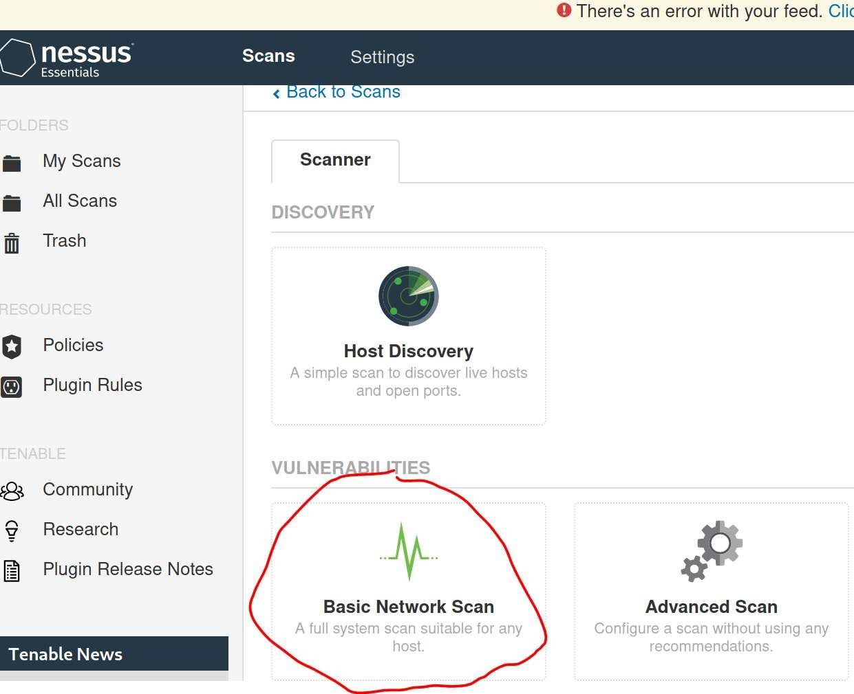

Fig 1.3

Step 6.

Name the target OS. Make a description of target. Input target IP address into “Targets”. Save the scan. Fig 1.4

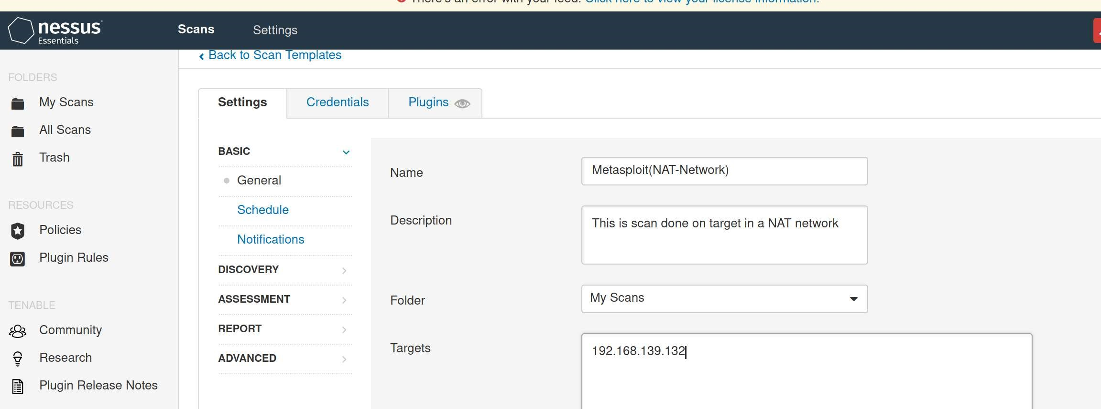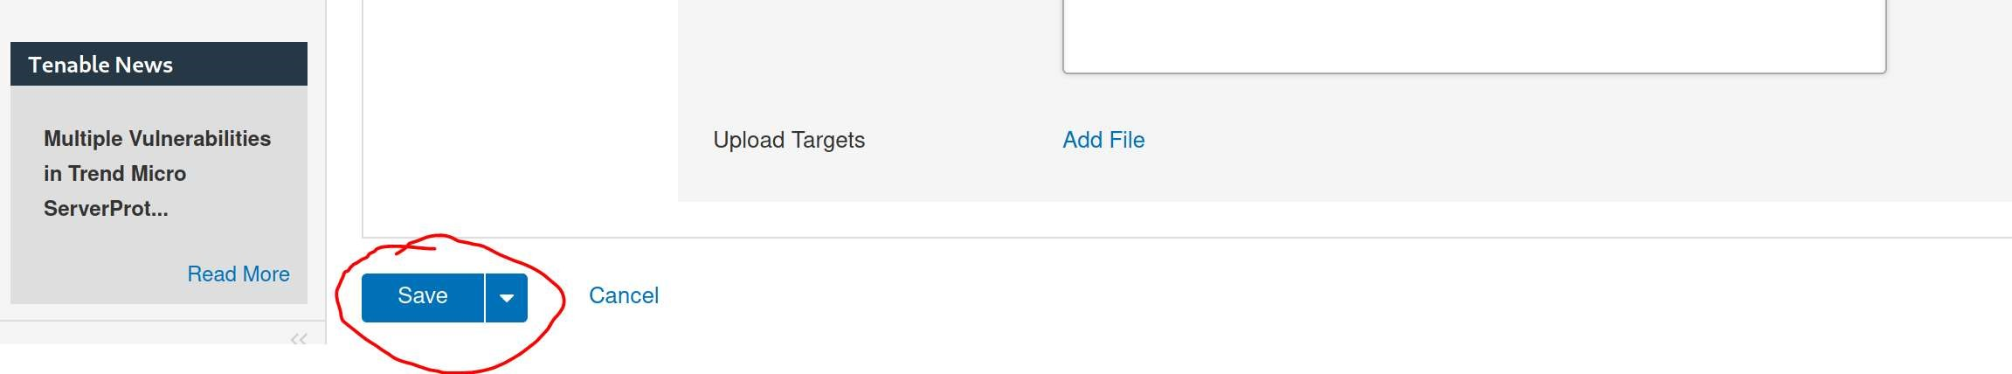

Fig 1.4

Step 7.

Find scan that was created and select the play button to launch scan. This will tell Nessus to start the scan on the target OS(Metasploitable). Fig 1.5

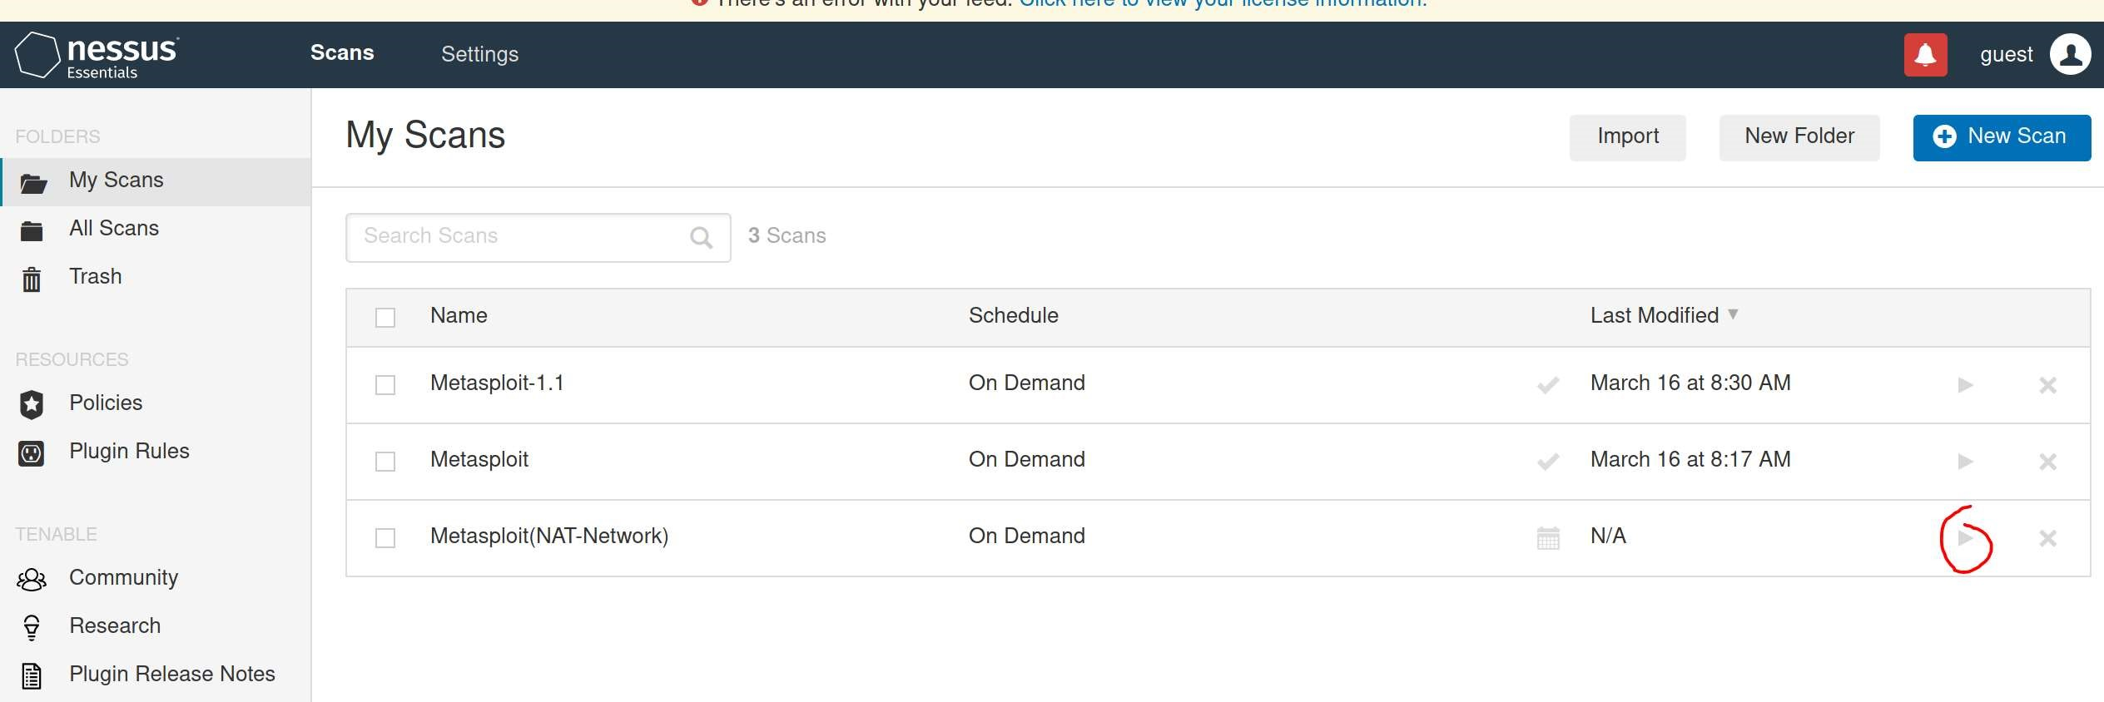

Fig 1.5

Step 8.

Wait for the scan to complete. Fig 1.6

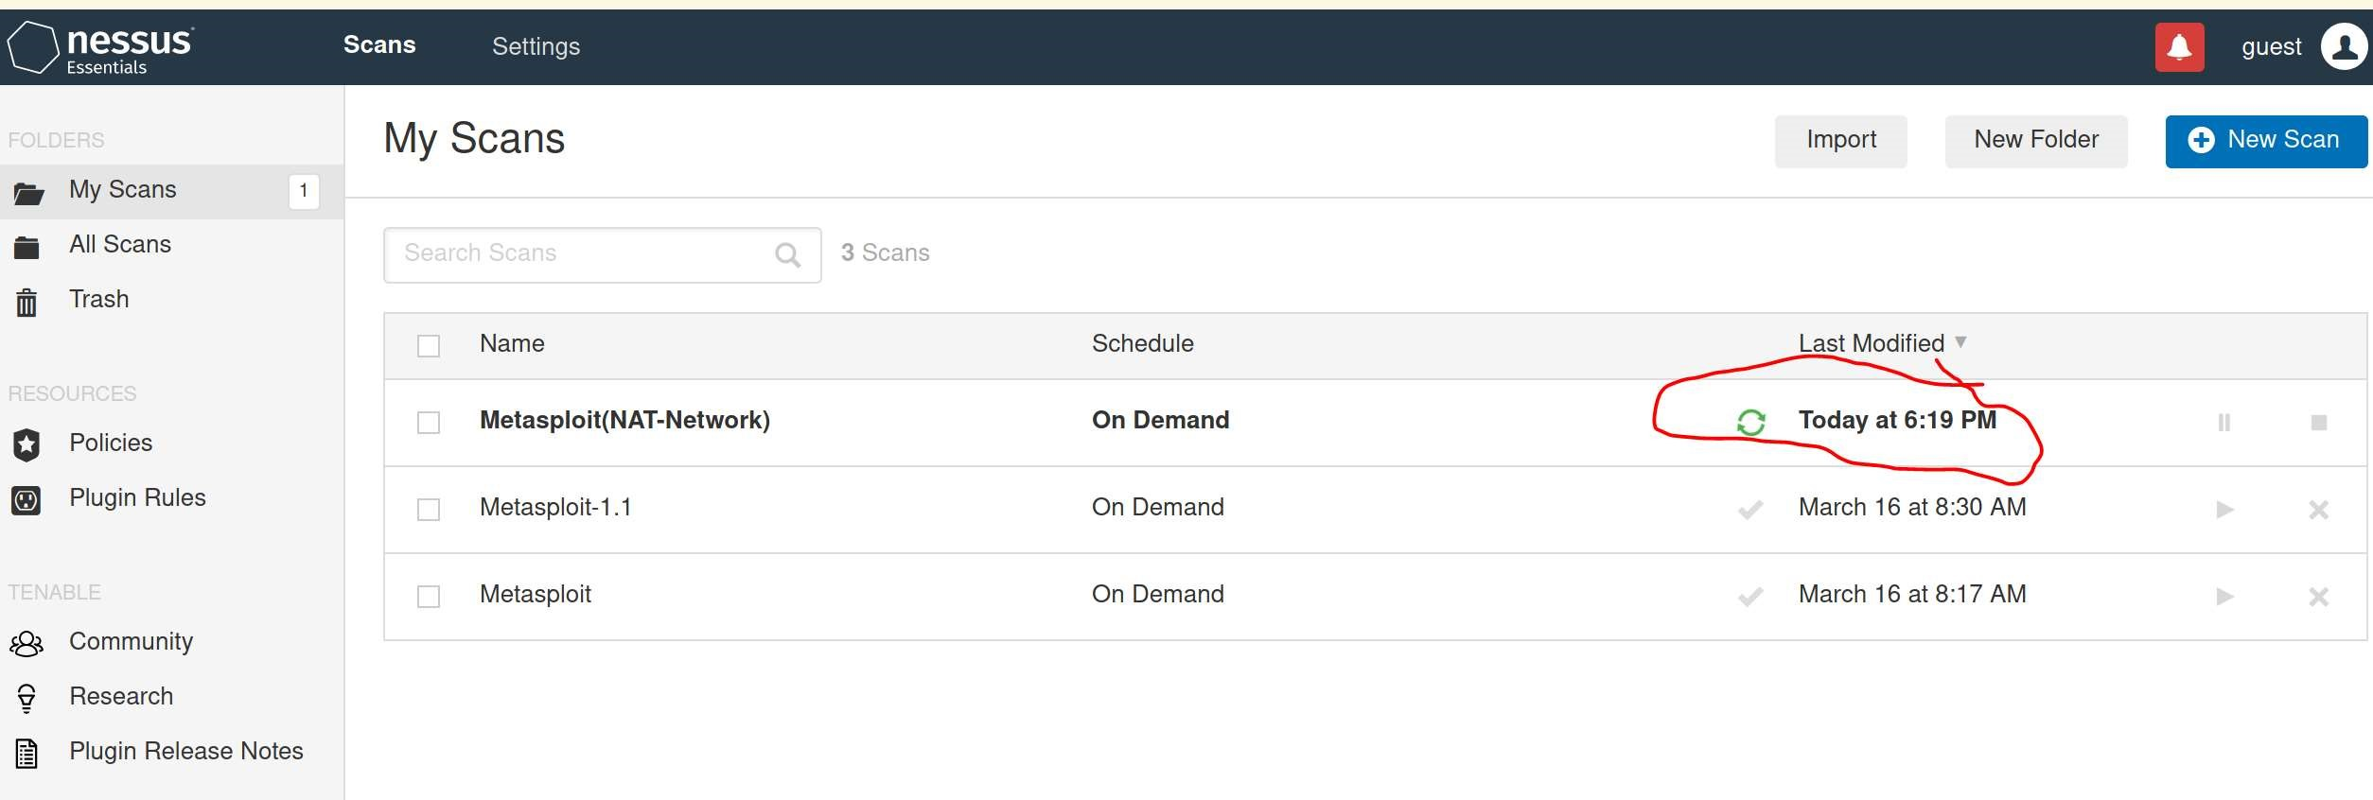

Fig 1.6

Step 9.

Click on the Metasploit(NAT-Network) file created to view the scan

Step 10.

Select the vulnerabilities tab to view vulnerabilities found. Fig 1.7

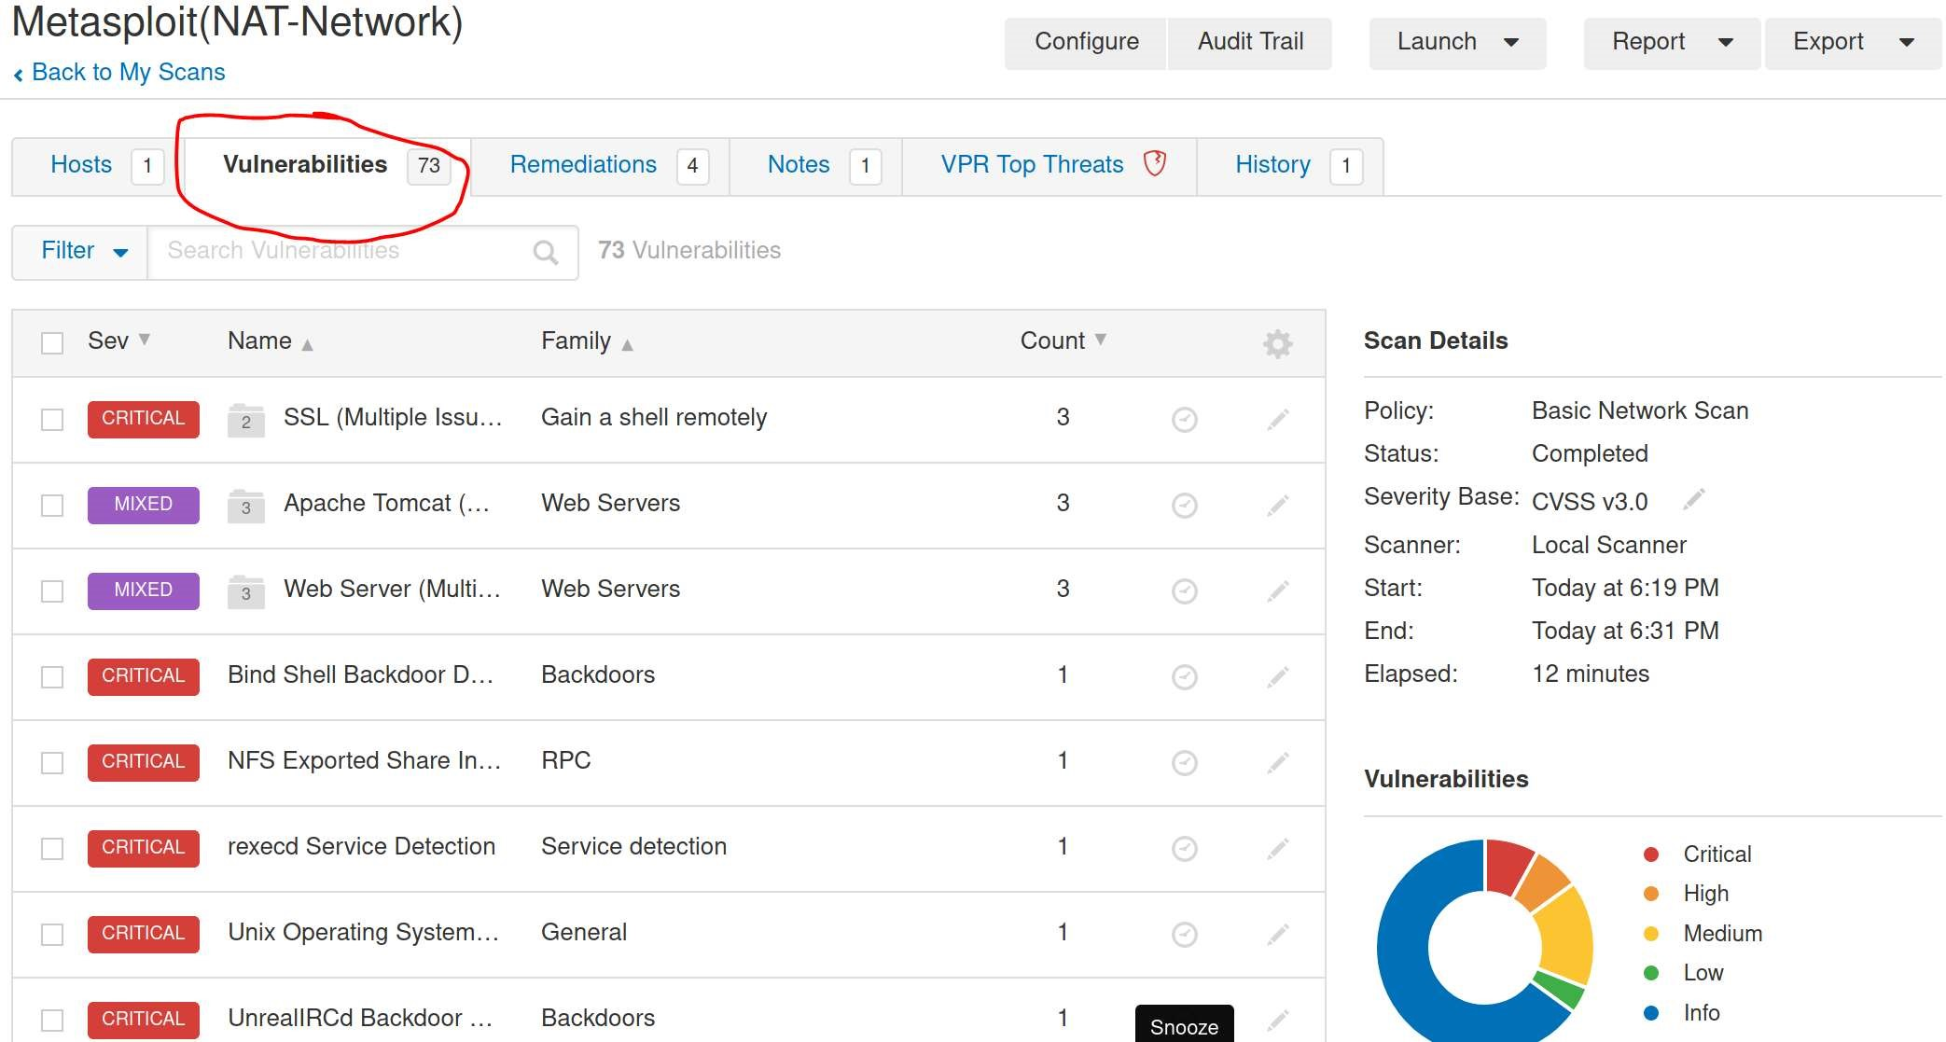

Fig 1.7

Step 11.

Download the generated report from Nessus. Select Report→PDF and then generate with the default Executive summary selected. Fig 1.8

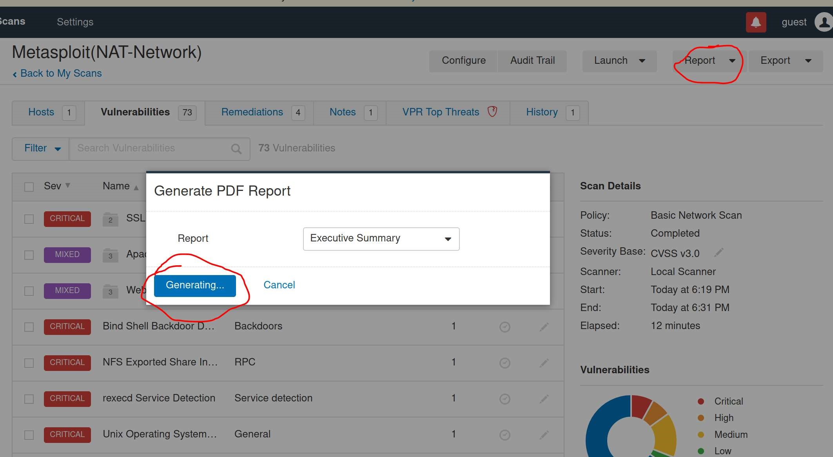

Fig 1.8

Nessus Report Results:

Metasploitable

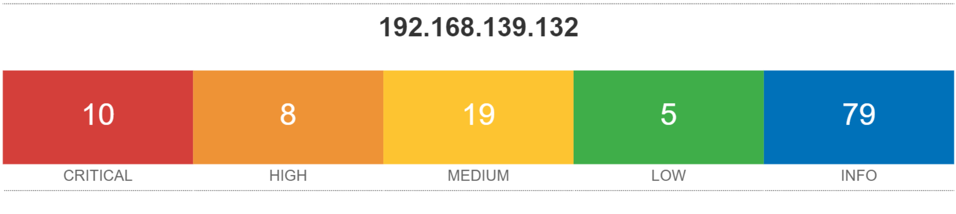

CentOS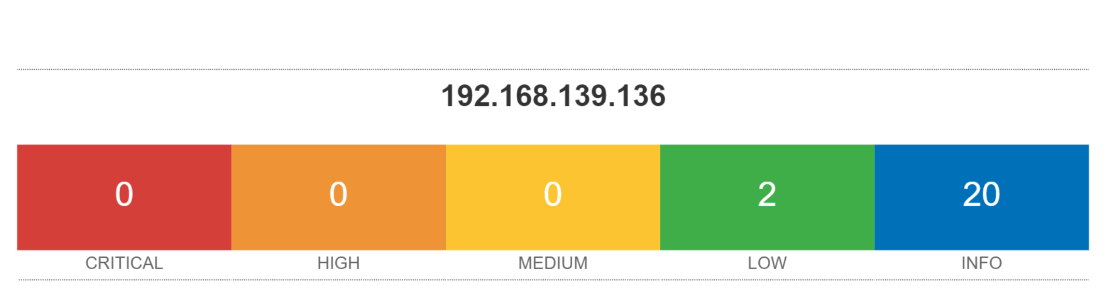

Fedora

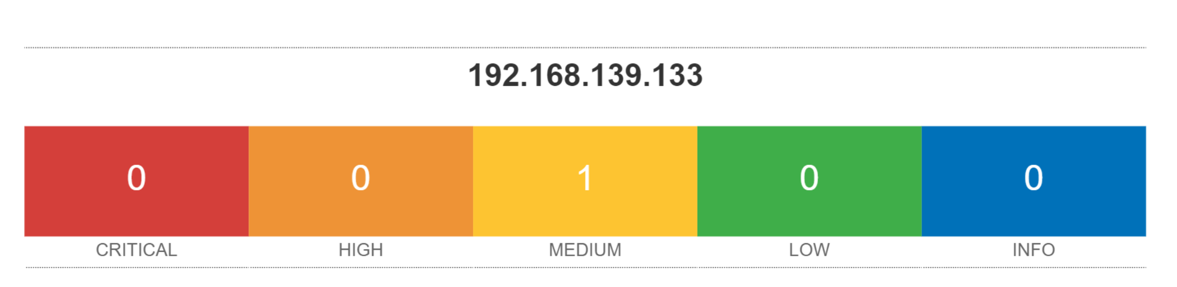

*Full Report on Git-Hub*

**Metasploit:**

Intro: …

Experimental Procedure:

It consists of (X#) steps

Step 1.

…

-Image display of the report at the end

Metasploitable Report Results:

Metasploitable does not have a generate report tool

**Recommendations:**

Based on our results, we recommend OpenVAS and Nessus for detecting vulnerabilities in an operating system because both are easy to use and provide details on vulnerabilities detected in a structured manner. These 2 vulnerability assessment systems are best for providing insight into the vulnerabilities we have in our chosen operating systems.

The details Nessus provides on vulnerability systems include how to patch vulnerability and vulnerability numbers that can be identified online for solutions to vulnerability.

What makes OpenVAS stand out in 1 sentence or 2(Devon)

Vulnerability Scaling:

Explain how Nessus scales it’s vulnerabilities

Explain how OpenVAS scales its vulnerabilities

On the other hand, we would recommend Metasploit for …(Exploitation?) because …

**Links**

Github:

<https://github.com/dsgarza/Computer-Systems-Security-Project.git>

Trello:

<https://trello.com/b/D8nc0ssm/comp-sys-sec-project#>

**Project Milestones: (Candan)**

Milestone 1

* Proposal

Description:

Our team will brainstorm a topic to implement in our project and present our project idea to our professor Gonzalo.

Milestone 2

* Develop a plan for the team project

Description:

Our team hosts a meeting at UIW to discuss what we will need to do for our project and layout a plan on how we should work on the project.

Our team concluded that we would

1st. Identify different vulnerability Assessment software’s we would use.

2nd. Identify Operating Systems to scan for vulnerabilities.

3rd. We need to set up a NAT configuration to create an isolated environment.

4th. Set up attacker OS and target OS, run software to scan OS, record steps to use software, generate a report, and upload our work into our group GitHub repository.

5th. Set up tasks for team members on our Trello account to show the progress of the team.

Milestone 3

* Identify Software and Operating Systems for operation.

Description:

Our team decided to use Nessus, Openvas, and Metasploit to scan the operating systems Fedora, CentOS, and Metasploitable.

Milestone 4

* Develop a network for virtual machines.

Description:

Our team configured our VMS to a NAT configuration to isolate them from our home networks.

Milestone 5

* Execute Software on operating Systems within the network.

Description:

Our Team will install our assigned vulnerability assessment scanners onto our personal computers kali Linux virtual machine.

Candan will install Nessus, Devon install OpenVAS and, Daniel install Metasploit.

All team members will install the OS’s Metasploitable, Fedora, and CentOS onto their own virtual machines configured to a NAT network.

Using our virtual kali Linux machine, each member will use their assigned software to scan for vulnerabilities on target operating systems Fedora, CentOS, and Metasploitable.

Milestone 6

* Record, analyze, and then discuss with the team on data.

Description:

Our team will take snap shots of the steps used to execute our vulnerability assessment software’s in a word document.

Our team will generate vulnerability reports from the software’s and uploaded to the teams GitHub repository of the group.

Meet with team to discuss which software was most effective and what operating system was most secure.

Milestone 7

* Create a Slide presentation
* Submit Final Report

Description:

Create a presentation of our project to present to our class.

Revise the initial report and submit a final report of the project.

**Current Status of Project:(Candan)**

The project is complete and software has been used to scan three operating systems

for vulnerabilities.

Next Steps:(Candan)

* Present project and submit onto Canvas assignments page

Expected Outcomes:(Candan)

* Have a model that can be used to identify the most effective Vulnerability assessment scanners.
* Identify the most effective and useful vulnerability scanner.

**Deliverables**

Deliverable 1.

Add member tasks in Trello Account-Link in table of contents. Fig. 2.1

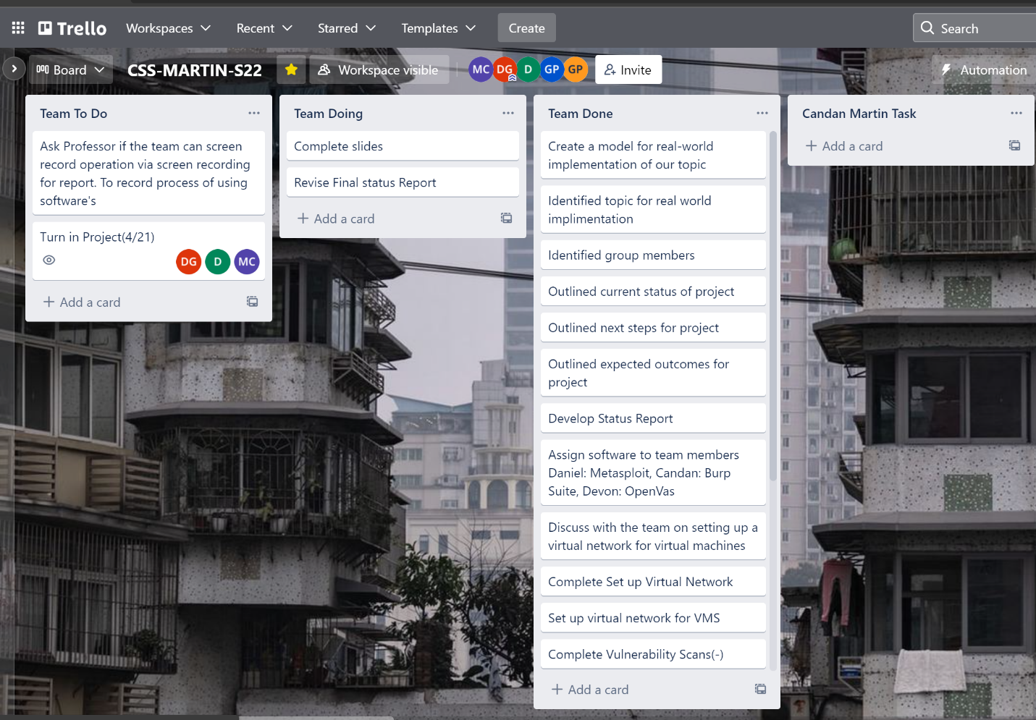

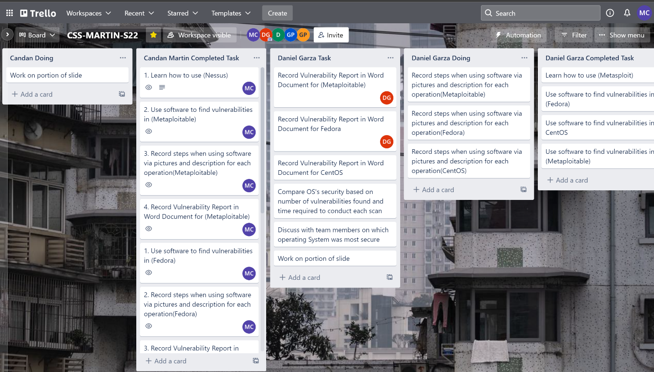

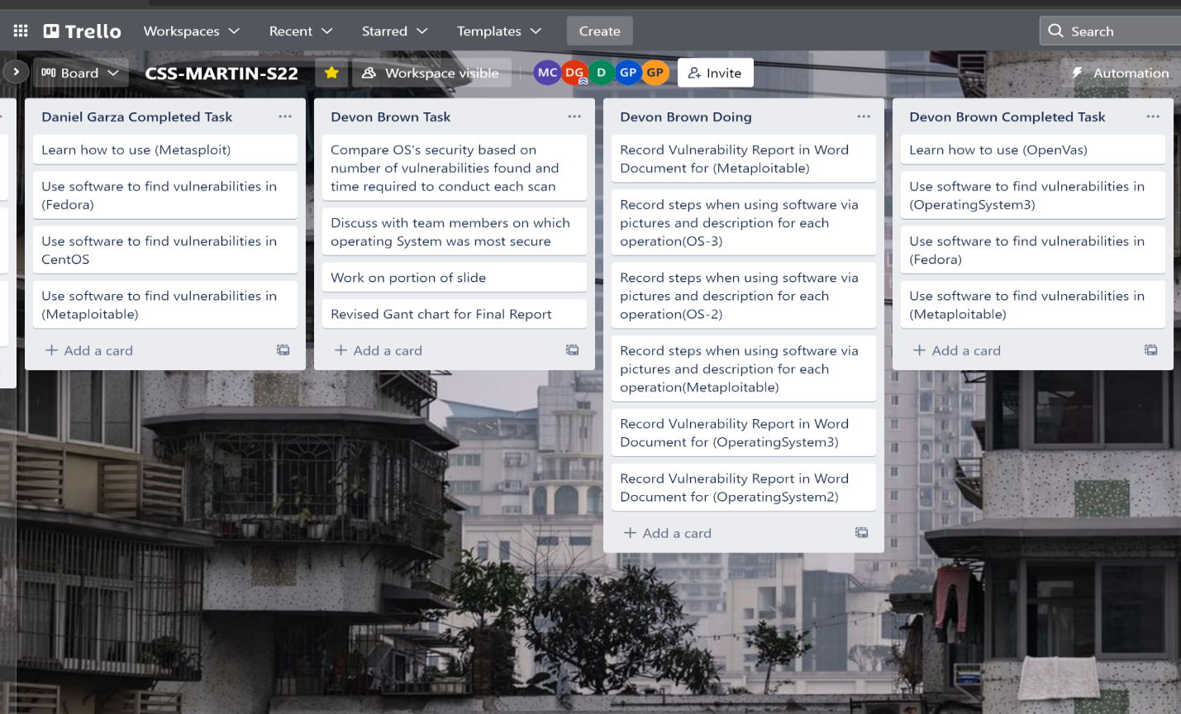

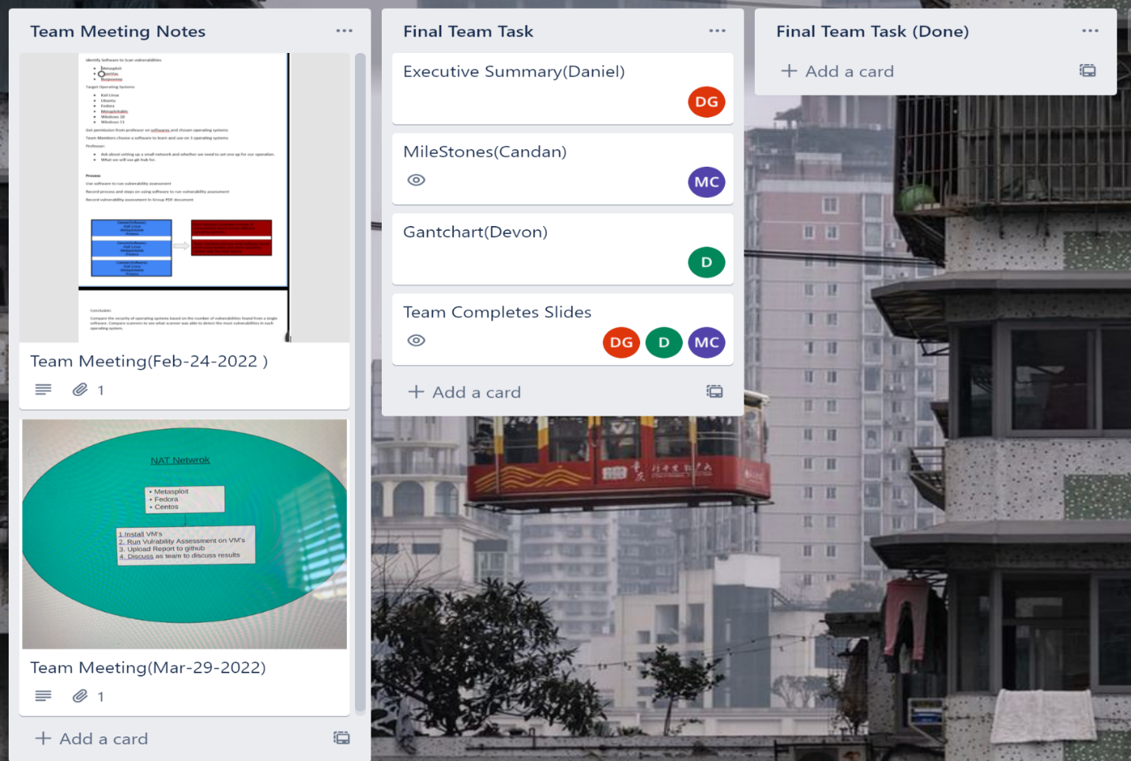

Fig. 2.1

Deliverable 2.

Documents showing how we used software and our generated reports were uploaded to team GitHub-Link in table of contents Fig. 2.2

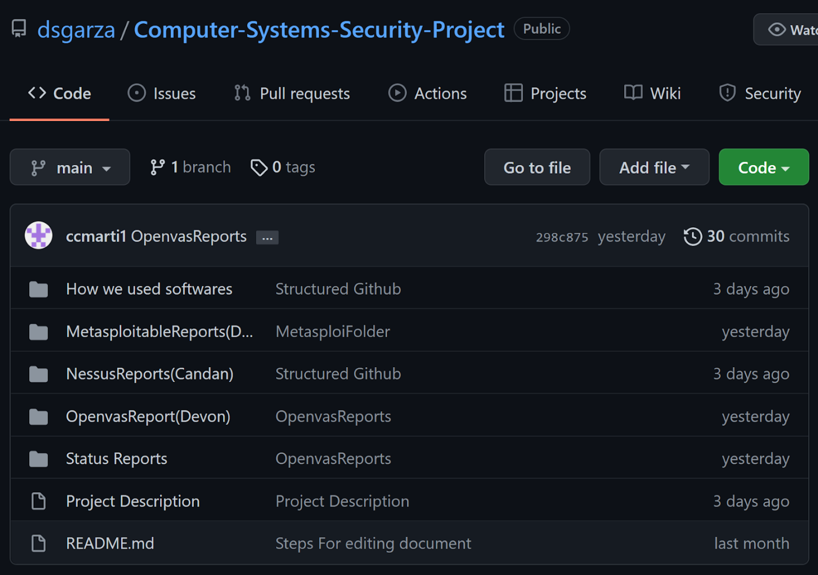

Fig. 2.2

Deliverable 3.

Presentation Slide Made Fig. 2.3

Link:

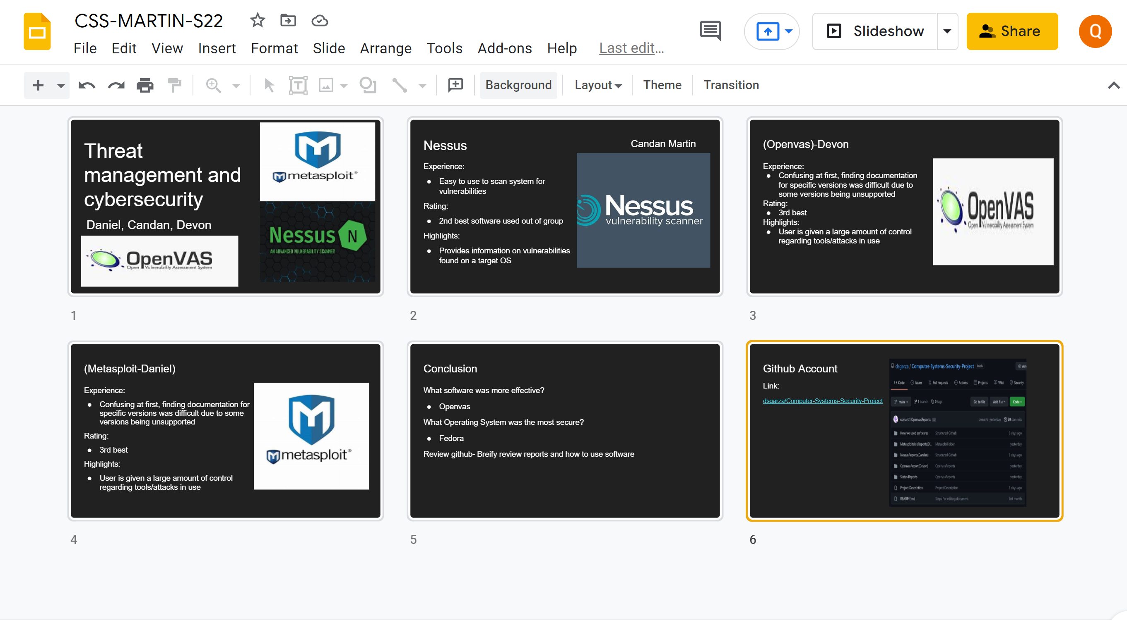

Fig. 2.3

Deliverable 4.

Initial visual display of how we will execute our project. Fig. 2.4

Changes made to design:

1. Burp suite has been changed to Nessus. Burp suite was miss-spelled as burpsweep.
2. Target Operating Systems changed to Metasploitable, Fedora, CentOS.

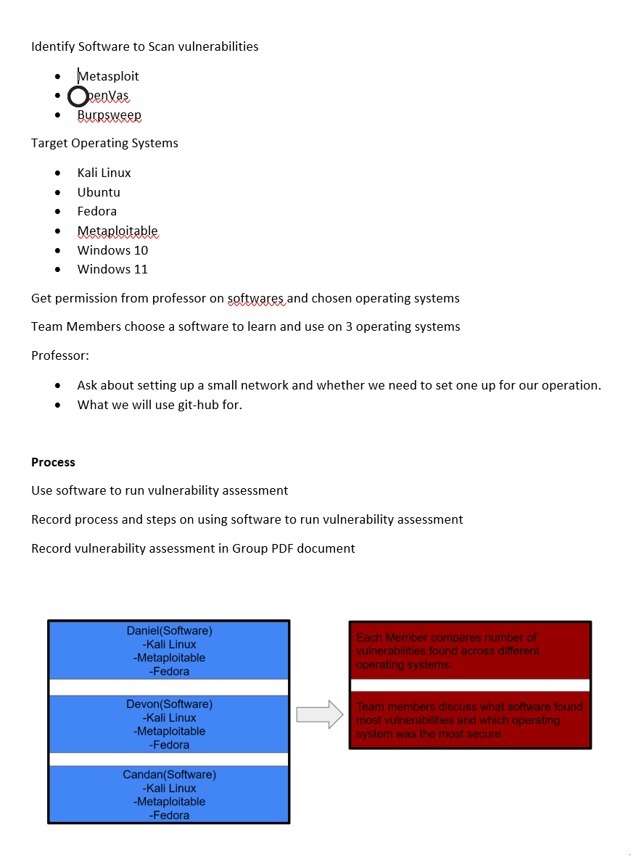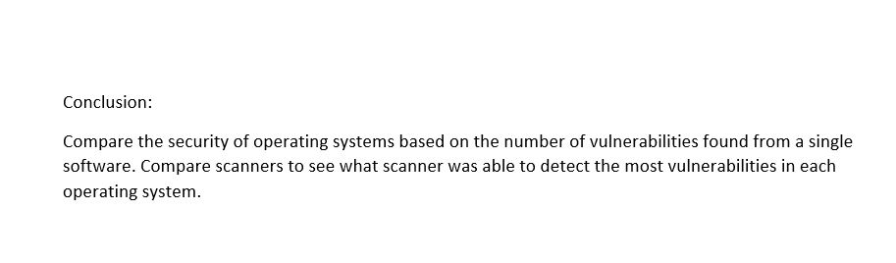Fig. 2.4

**Professional Accomplishments**

1. Learn to work in a collaborative environment in a team.
2. Development of skills in project management and constructing a plan to implement a task given. Our task given was implementing the topic our team chose.

**Individually**

Candan:

1. Learned how to use Nessus to scan operating systems.
2. Learned how to structure plans for project implementation and collaborate with the team for ideas.
3. Learned how to configure NAT network.

Daniel:

1. Learned how to use Armitage software.
2. Learned how to work Unix/Linux operating systems efficiently.
3. Learned time/project management.

Devon:

Put what you were able to learn during the project. Maybe software and Gant chart.

**Project Schedule Management**

Gantt chart(Devon)

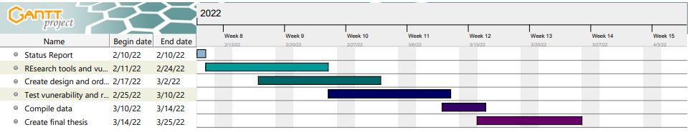

COMMENTS

-Gonzalo Parra just made a new comment on the submission for Candan Martin for Status Report

Excellent, make sure you **build some good case scenarios** and **present their corresponding demos.** Also, make sure you **follow the format I provided** you. Make sure you **update your Gantt chart and Trello** as soon as you start defining the tasks for each milestone.(**Once you start defining task for each milestone**)

**Credits Page**

**Executive Summary**

Contributors: Daniel and Candan

* OpenVAS Results
* OpenVas Generated Report

Contributors: Devon

* Nessus Results
* Nessus Generated Report

Contributors: Candan

* Metasploit Results
* Metasploit Generated Report

Contributors: Daniel

* Recommendations

Contributors: Devon, Daniel and Candan

**Links**

**Project Milestones**

Contributors: Candan

* Current Status of Project
* Next Steps
* Expected Outcomes

Contributors: Candan

**Deliverables**

Contributors: Candan

**Professional Accomplishments**

Contributors: Devon, Daniel and Candan

* Candan Professional Accomplishments
* Daniel Professional Accomplishments
* Devon Professional Accomplishments

**Project Schedule Management**

Contributors: Devon and Candan

* Gant Chart

Contributors: Devon

**Credits Page**

Contributors: Candan

**Table of Contents**

Contributors: Candan

**Table of Contents**

|  |  |
| --- | --- |
| Executive Summary (Daniel & Candan)  OpenVAS Results  OpenVAS Generated Report  Nessus Results  Nessus Generated Report  Metasploit Results  Metasploit Generated Report  Recommendations | #  #  #  #  #  #  #  # |
| Links | # |
| Project Milestones  Current Status of Project  Next Steps  Expected Outcomes | #  #  #  # |
| Deliverables | # |
| Professional Accomplishments  Candan Professional Accomplishments  Daniel Professional Accomplishments  Devon Professional Accomplishments | #  #  #  # |
| Credits Page | # |